Nama : Neta Aulya Kurnia Ningrum

Tugas 3 Figma

1. A. 

B. 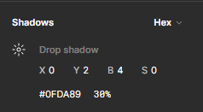

d. 

e. 

1. 